Statistics Lecture 7.4: Confidence Interval for the Sample Mean, Population Std Dev -- Unknown

Estimating Population Mean 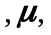 without knowing the population Standard Deviation :

If you do not know you cannot use a z-score.
Instead, we use a T-score:

T-score:
- Random sample
- n is sample size
  - 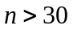 or
  - 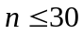 - The population must be normally distributed, Then the sampling distribution of the sample mean will be normally distributed.

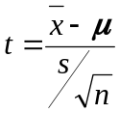 Sample standard deviation is denoted by: s 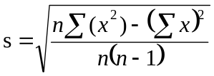

Critical values are given by 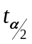:

Degrees of Freedom:
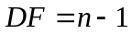 Sample size minus one.

Example:
Sample 23 from a normally distributed population.
Find the critical value for a confidence level of 95 percent.

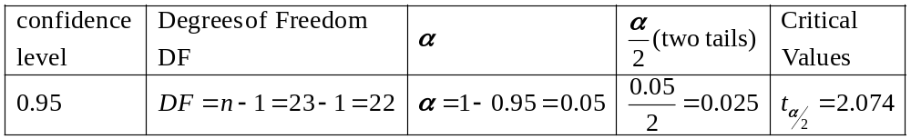

Note: as sample sizes increase the t-scores gets closer to a z-score. (approaches)

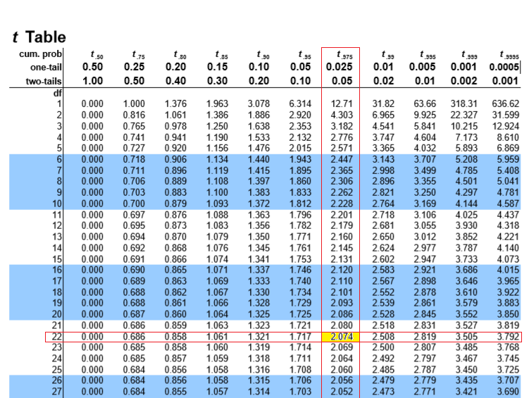
Margin of error:
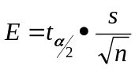

Confidence intervals
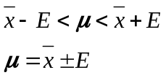

Steps:
- check requirements.
- Find Degrees of freedom
- Find critical value. 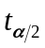 for a given confidence level
- Find the margin of Error 
- Find confidence interval 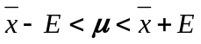

Example:
Construct a 95% confidence interval for the average age of people denied promotion from a company
In a random sample of 23 people the average age was 47.0 with a standard deviation of 7.2.
Assume this sample comes from a population that is normally distributed.

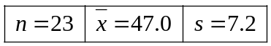
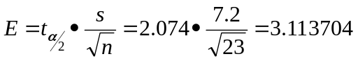
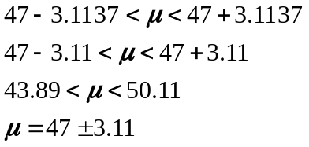

I don’t know what the population mean is but I am 95% sure that the people being denied promotion
is between 44 and 50 years of age.

Finding Sample mean () and Margin of error ()

To find sample mean
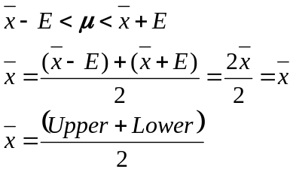

To find Margin of error
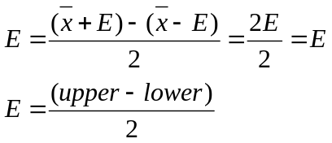

Example
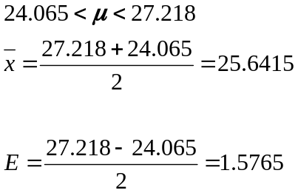
Example:
In a random sample of a 190 babies born to cocaine using mothers,
the average birth weight was found to be 2700 grams with a standard deviation of 645 grams.
Construct a 99% confidence interval for the population average birth weight.
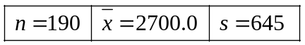

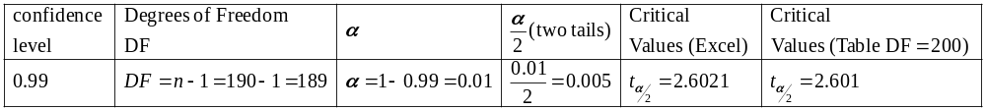

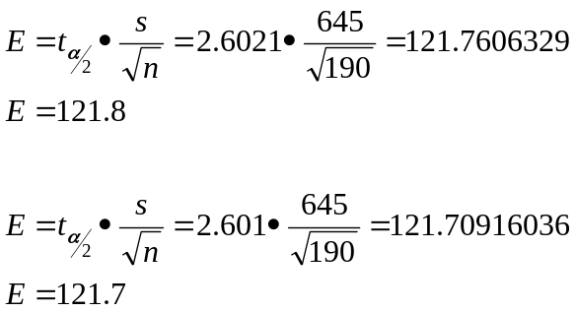

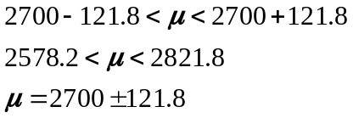

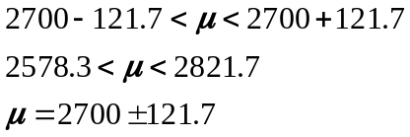

I don’t know what the average birth weight of the population of cocaine using mother is but I am 99% sure that the populations average birth weight for babies being born is between 2578.2 and 2821.8 grams.

